Report
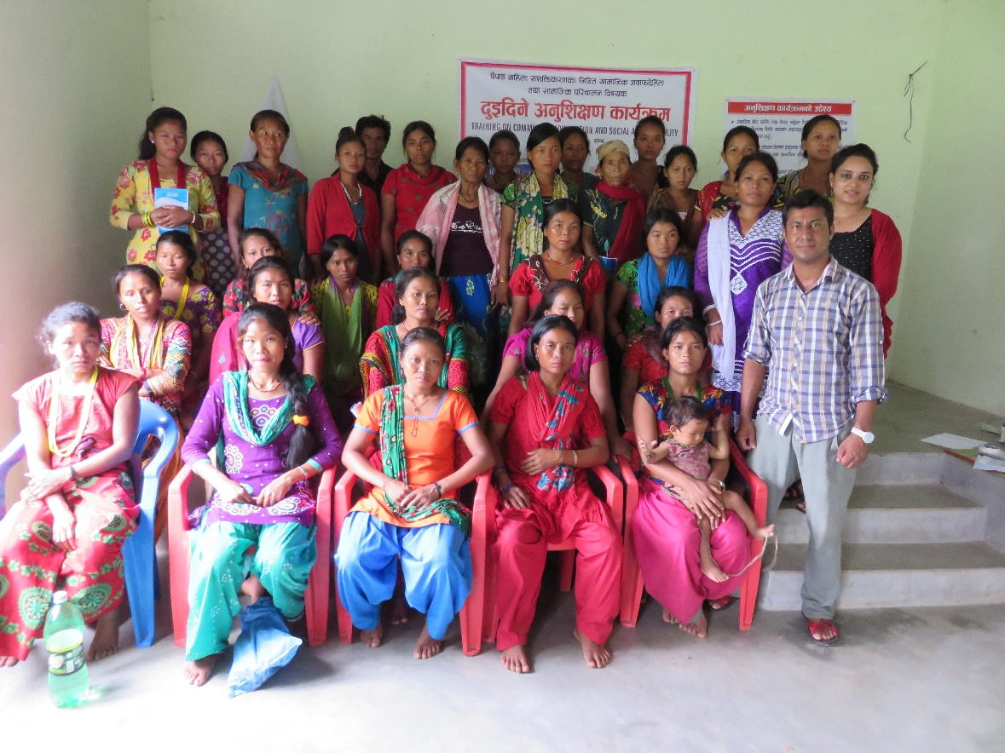
Organized by Funding Assistance :
DEC- Nepal UNDEF
Capacity Building Partner
SAP- Nepal

Local partner :
Nepal Chepang Association
Contents
1. Background 3
2. Objectives 3
3. Participants and Facilitators 3
4. Training Schedule 3
5. Methodology 4
6. Contents Covered in the training 4
7. Evaluation 4
8. Conclusion 4
Annex: I – Participants list 5
Annex- II – Glimpse of cascade training 11
Annex III-Schedule of the training program 13

Cascade Training Report

1. Background
Development Exchange Center organized a two days cascade training each in six Village Development Committees (VDCs) in joint partnership with National Chepang Association as Local Partner and South Asia Partnership as Capacity Building Partner in funding assistance of UNDEF. These events were organized in Siddhi, Shaktikhor, Kaule, Korak, Lothar, Chandibhanjyang from August 16 to September 8, 2015.

2. Objectives
The major objective of the cascade training was to enhance leadership capacity and networking skills of Chepang women. However, major specific objectives were:
- To increase facilitation skills of Local Resource Persons (LRPs) enabling them to inspire other Chepang women to raise their concerns.
- To increase knowledge of Chepang women on local governance planning process, Social Accountability and Social Mobilization

3. Participants and Facilitators
Altogether 185 participants participated in this training. most of these participants were the executive members (President, Secretary, Treasurer, Vice President, Joint Secretary, and member) from 30 Women Chepang Action Fora (WoCAF). Among these participants 10 were Chepang males who were there to support Chepang empowerment process through their inputs to these groups. These training programs were conducted in initiation of Female Local Resource Persons of the project. Project coordinator Mr. Karki facilitated these program and Monitoring and Evaluation officer supported all these training events and collected necessary information and data from the training.

4. Training Schedule
The cascade trainings were conducted in following dates in following locations
Name of VDCs | Date of Training | Training Site
Korak VDC | 16 – 17 August 2015 | Dobaate, Khahare Korak VDC office
Lother VDC | 20 – 21 August 2015 | Lothar VDC, Tapang
Kaule VDC Hattibang | 23 – 24 August 2015 | Hapani School
Chandibhanjang VDC, Kalikhola | 26 – 27 August 2015 | Adamara School
Shaktikhor VDC | 5 – 6 September 2015 | Community Forest Office at Shaktikhor
Siddhi VDC | 7 – 8 September 2015 | Siddhi VDC Office

5. Methodology
The training was facilitated in a participatory manner during all training sessions. The content of the training were printed in flex. The Local Resource Persons first explained the contents to the participants and later the content was elaborated by project coordinator. Illustrations were also used simultaneously in every content. Games, storytelling, role play, group work, presentation etc were the methods and tools used in this training.

6. Contents Covered in the training
The contents covered in the training were gender, equity and equality, social mobilization concept, qualities of social mobilizer, facilitation skills, concept of reflect model, steps of budget planning process, intervention of Chepang Women in Budget planning process at VDC level, role of WoCAF, concept of Social Accountability and its tools like Community Score Card (CSC), Public Hearing, Social Audit with highlight on CSC.

7. Evaluation
The training program was very participatory this helped the participants open up more on the final day of the training. Participants appreciated the training, Ms. Dil Maya Chepang from Siddhi VDC said, “I learnt many important things from this training. All these things were new to me. VDCs have 10% of its total budget for women, and separate budget for children. Ihad no idea about this. Now I shall share this information with other members from WoCAF. I also learnt females are equally capable as males, environment and opportunity should be provided to them. So, we should not discriminate between a son and a daughter, should educate them equally.” There was positive response from all the participants regarding effectiveness of this training.
Some of the participants expressed their learning and thanked the organizations supporting this program to empower local Chepang women through folk songs composed by them.

8. Conclusion
Cascade training was one of the important events of this project. The event was organized in a very participatory manner with good flow of contents and effective use of flex, illustrations. Games, presentation, storytelling, role play, group work made it more practical and entertaining besides this the participants also gave positive response to this event. With all these positive aspect this cascade training was very effective. The participants committed to share their learning with their respective WoCAF members.

Annex: I – Participants list
Participants from Siddhi
S. N. | Name of the Participants | Name of their group | Designation of the Participants in the Group | Address
1 | Bipana Chepang | Shadev WoCAF | President | Siddhi, 6
2 | Sajina Chepang | Shadev WoCAF | Secretary | Siddhi, 6
3 | Akil Maya Chepang | Shadev WoCAF | Vice-President | Siddhi, 6
4 | Sita Chepang | Shadev WoCAF | Joint Secretary | Siddhi, 6
5 | Bima Chepang | Shadev WoCAF | Treasurer | Siddhi, 6
6 | Dhana Maya Chepang | Shadev WoCAF | Member | Siddhi, 6
7 | Usha Chepang | Sun Rise WoCAF | President | Siddhi, 6
8 | Nima Chepang | Sun Rise WoCAF | Secretary | Siddhi, 6
9 | Rita Maya Chepang | Sun Rise WoCAF | Vice-President | Siddhi, 6
10 | Jharana Chepang | Sun Rise WoCAF | Joint Secretary | Siddhi, 6
11 | Bindu Maya Chepang | Sun Rise WoCAF | Treasurer | Siddhi, 6
12 | Pili Maya Chepang | Sun Rise WoCAF | Member | Siddhi, 6
13 | Sunita Chepang | Whoiling WoCAF | President | Siddhi, 6
14 | Rabina Chepang | Whoiling WoCAF | Secretary | Siddhi, 6
15 | Sushila Chepang | Whoiling WoCAF | Vice-President | Siddhi, 6
16 | Joshmi Chepang | Whoiling WoCAF | Joint Secretary | Siddhi, 6
17 | Shanti Maya Chepang | Whoiling WoCAF | Treasurer | Siddhi, 6
18 | Sunita Chepang | Whoiling WoCAF | Member | Siddhi, 6
19 | Mancha Maya Chepang | Symrang WoCAF | President | Siddhi, 6
20 | Dil Maya Chepang - A | Symrang WoCAF | Secretary | Siddhi, 6
21 | Mema Maya Chepang | Symrang WoCAF | Vice-President | Siddhi, 6
22 | Dil Maya Chepang - B | Symrang WoCAF | Joint Secretary | Siddhi, 6
23 | Shauni Maya Chepang | Symrang WoCAF | Member | Siddhi, 6
24 | Lal Maya Chepang | Symrang WoCAF | Member | Siddhi, 6
25 | Mansiha Chepang | Deujar WoCAF | Vice-President | Siddhi, 6
26 | Dil Kumari Chepang | Deujar WoCAF | Joint Secretary | Siddhi, 6
27 | Mit Maya Chepang | Deujar WoCAF | President | Siddhi, 6
28 | Raj Kumari Chepang | Deujar WoCAF | Member | Siddhi, 6
29 | Shila Maya Chepang | Deujar WoCAF | Member | Siddhi, 6
30 | Manju Maya Chepang | Deujar WoCAF | Treasurer | Siddhi, 6
31 | Kamala Chepang | DEC Nepal | Local Resource Person | Siddhi, 6
32 | Asha Chepang | DEC Nepal | Local Resource Person | Siddhi, 6
33 | Anita Chepang | DEC Nepal | Local Resource Person | Siddhi, 6
34 | Dipak Chepnag | DEC Nepal | Influencial Male Leaders | Siddhi, 6

Participants from Lothar
S. N. | Name of the Participants | Name of their group | Designation of the Participants in the Group | Address
1 | Rayjina Chepang | DEC Nepal | Local Resource Person | Lothar, 4
2 | Kabita Chepang | DEC Nepal | Local Resource Person | Lothar, 9
3 | Rina Chepang | DEC Nepal | Local Resource Person | Lothar, 4
4 | Remika Chepang | Gundi WoCAF | President | Gundi, 4
5 | Shahara Chepang | Gundi WoCAF | Secretary | Gundi, 4
6 | Harimaya Chepang | Gundi WoCAF | member | Gundi, 4
7 | Amrita Chepang | Gundi WoCAF | Joint-Secretary | Gundi, 4
8 | Bibitra Chepang | Gundi WoCAF | Treasurer | Gundi, 4
9 | Buddhi Maya Chepang | Gundi WoCAF | Vice-President | Gundi, 4
10 | Pabitra Chepang | Polping WoCAF | Secretary | Lothar, 8
11 | Kamala Chepang | Polping WoCAF | Vice-President | Lothar, 8
12 | Kumari Chepang | Polping WoCAF |  | Lothar, 7
13 | Phool Maya Chepang | Polping WoCAF |  | Lothar, 8
14 | Asmita Chepang | Polping WoCAF |  | Lothar, 7
15 | Pasang Chepang | Polping WoCAF |  | Lothar, 7
16 | Chameli Chepang | Syamrang WoCAF
17 | Lalmaya Chepang | Syamrang WoCAF
18 | Dilmaya Chepang | Syamrang WoCAF | Member
19 | Aaitimaya Chepang | Syamrang WoCAF
20 | Bimala Chepang | Syamrang WoCAF | Vice-President | Lothar, 9
21 | Ram Maya Chepang | Chyoding WoCAF |  | Lothar, 9
22 | Sumitra Chepang | Chyoding WoCAF | Member | Lothar, 9
23 | Nirmaya Chepang | Chyoding WoCAF | Secretary | Lothar, 9
24 | Kaddimaya Chepang | Chyoding WoCAF |  | Lothar, 9
25 | Sunamaya Chepang | Chyoding WoCAF | Vide-President | Lothar, 9
26 | Dilmaya Chepang | Chyoding WoCAF | Member | Lothar, 9
27 | Sharita Chepang | Chyoding WoCAF | Treasurer | Lothar, 9
28 | Kalimaya Chepang | Tapang WoCAF | President | Lothar, 4
29 | Yaanimaya Chepang – A | Tapang WoCAF | Vice-President | Lothar, 4
30 | Yaanimaya Chepang – B | Tapang WoCAF | Secretary | Lothar, 4
31 | Jhupimaya Chepang | Tapang WoCAF | Tresurer | Lothar, 4
32 | Indra Kumari Chepang | Tapang WoCAF | Member | Lothar, 4
33 | Anita Chepang | Tapang WoCAF | Member | Lothar, 4

Participants from Kaule
S.N. | Name of the participants | Name of their Women Chepang Action Fora (WoCAF) | Designation of the Participants in the Group
1 | Phool Maya Chepang | DEC Nepal | Local Resource Person
2 | Phool Mati Chepang | DEC Nepal | Local Resource Person
3 | Pratika Chepang | Digo WoCAF | Secretary
4 | Namrata Chepang | Digo WoCAF | Vice President
5 | Mishra Kurami Chepang | Digo WoCAF | Treasurer
6 | Santa Bahadur Chepang | Digo WoCAF | Member
7 | Asha Chepang | Dumkim WoCAF | Secretary
8 | Kul Maya Chepang | Dumkim WoCAF | Vice President
9 | Hari Maya Chepang | Dumkim WoCAF | Treasurer
10 | Subha Kumari Chepang | Dumkim WoCAF | Member
11 | Ritu Chepang | Dumkim WoCAF | Joint Secretary
12 | Rita Chepang | Dumkim WoCAF
13 | Nani Maya Chepang | Dumkim WoCAF
14 | Rasikha Chepang | Siddhi Kalika WoCAF | Secretary
15 | Om Kumari Chepang | Siddhi Kalika WoCAF | Vice President
16 | Shita Chepang | Siddhi Kalika WoCAF | Treasurer
17 | Suku Maya Chepang | Siddhi Kalika WoCAF | Member
18 | Ati Maya Chepang | Siddhi Kalika WoCAF | Joint Secretary
19 | Man Kumari Chepang | Siddhi Kalika WoCAF
20 | Dil Kumari Chepang | Siraichuli WoCAF | President
21 | Runata Chepang | Siraichuli WoCAF | Secretary
22 | Krishna Mati Chepang | Siraichuli WoCAF | Vice-President
23 | Som Maya Chepang | Siraichuli WoCAF | Joint Secretary
24 | Dalli Maya Chepang | Siraichuli WoCAF | Treasurer
25 | Shita Chepang | Siraichuli WoCAF | Member
26 | Amrika Chepang | Hattibang WoCAF | President
27 | Manu Chepang | Hattibang WoCAF | Secretary
28 | Lalita Chepang | Hattibang WoCAF | Vice-President
29 | Kalpana Chepang | Hattibang WoCAF | Joint Secretary
30 | Mana Kumari Chepang | Hattibang WoCAF | Treasurer
31 | Gaumaya Chepang | Hattibang WoCAF | Member
32 | Bishnu Maya Chepang | Hattibang WoCAF | Member
33 | Nira Chepang | Hattibang WoCAF | Member
34 | Raj Bahadur Chepang | DEC Nepal | Influencial Male Leaders

Participants from Chandibhanjyang
S.N. | Name of the Participant | Name of their Women Chepang Action Fora (WoCAF) | Designation of the participants in the group | Address
1 | Laxmi Chepang | DEC Nepal | LRP
2 | Mana Maya Chepang | DEC Nepal | LRP
3 | Maya Chepang | Akata WoCAF | Secretary | Chandibhanjyang,6
4 | Indra Maya Chepang | Akata WoCAF | President | Chandibhanjyang,6
5 | Bhari Chepang | Akata WoCAF |  | Chandibhanjyang,6
6 | Mana Maya Chepang | Akata WoCAF | Vice- President | Chandibhanjyang,6
7 | Kanchimaya Chepang | Akata WoCAF | Member | Chandibhanjyang,6
8 | Kumari Chepang | Akata WoCAF | Tresurer | Chandibhanjyang,6
9 | Raykha Chepang – A | Samjhana WoCAF | President | Chandibhanjyang, 5
10 | Chandra Kumari Chepang | Samjhana WoCAF | Joint Secretary | Chandibhanjyang, 5
11 | Shila Chepang | Samjhana WoCAF | Secretary | Chandibhanjyang, 5
12 | Raykha Chepang- B | Samjhana WoCAF | Treasurer | Chandibhanjyang, 5
13 | Mangali Maya Chepang | Samjhana WoCAF | Vice- President | Chandibhanjyang, 5
14 | Ram Kumari Chepang | Samjhana WoCAF | Member | Chandibhanjyang, 5
15 | Susmita Chepang | Namuna WoCAF | President | Chandibhanjyang, 6
16 | Surya Kumari Chepang | Namuna WoCAF | Secretary | Chandibhanjyang, 6
17 | Samjhana Chepang | Namuna WoCAF | Joint Secretary | Chandibhanjyang, 6
18 | Asmita Chepang | Namuna WoCAF | Treasurer | Chandibhanjyang, 6
19 | Shakuntala Chepang | Namuna WoCAF | Vice- President | Chandibhanjyang, 6
20 | Parbati Chepang | Namuna WoCAF | Member | Chandibhanjyang, 6
21 | Gyanu Maya Chepang | Milan WoCAF | President | Chandibhanjyang, 6
22 | Shila Chepang | Milan WoCAF | Secretary | Chandibhanjyang, 6
23 | Rammaya Chepang | Milan WoCAF | Joint Secretary | Chandibhanjyang, 6
24 | Lal Maya Chepang | Milan WoCAF | Treasurer | Chandibhanjyang, 6
25 | Chandra Kumari Chepang | Milan WoCAF | Vice- President | Chandibhanjyang, 6
26 | Samjhana Chepang | Milan WoCAF | Member | Chandibhanjyang, 6
27 | Maya Chepang | Shakriya WoCAF | President | Chandibhanjyang, 6
28 | Bimala Chepang | Shakriya WoCAF | Secretary | Chandibhanjyang, 6
29 | Dil Maya Chepang | Shakriya WoCAF | Joint Secretary | Chandibhanjyang, 6
30 | Ritu Chepang | Shakriya WoCAF | Treasurer | Chandibhanjyang, 6
31 | Sunita Chepang | Shakriya WoCAF | Vice- President | Chandibhanjyang, 6
32 | Nisha Chepang | Shakriya WoCAF | Member | Chandibhanjyang, 6

Participants from Korak
S.N. | Name of the Participant | Name of their Women Chepang Action Fora (WoCAF) | Designation of the participants in the group | Address
1 | Ganga Maya Chepang | DEC Nepal | Local Resource Person | Korak 8
2 | Kamala Chepang | DEC Nepal | Local Resource Person | Korak 8
3 | Chandra Kumari Chepang | DEC Nepal | Local Resource Person | Korak 6
4 | Suna Maya Chepang | Srijana WoCAF | President | Korak, 8
5 | Buddhi Maya Chepang | Srijana WoCAF | Secretary | Korak, 8
6 | Pabitra Chepang | Srijana WoCAF | Vice-President | Korak, 8
7 | Asmita Chepang | Srijana WoCAF | Joint Secretary | Korak, 8
8 | Iswari Chepang | Srijana WoCAF | Treasurer | Korak, 8
9 | Dil Kumari Chepang | Srijana WoCAF | Member | Korak, 8
10 | Sabitri Chepang | Chetanshil WoCAF | President | Korak, 5
11 | Bishnu Maya Chepang | Chetanshil WoCAF | Secretary | Korak, 5
12 | Chari Maya Chepang | Chetanshil WoCAF | Vice-President | Korak, 5
13 | Neeta Chepang | Chetanshil WoCAF | Joint Secretary | Korak, 5
14 | Sangeeta Chepang | Chetanshil WoCAF | Treasurer | Korak, 5
15 | Bhakti Maya Chepang | Chetanshil WoCAF | Member | Korak, 5
16 | Shanti Chepang | Wakanti WoCAF | President | Korak, 9
17 | Dhana Maya Chepang | Wakanti WoCAF | Secretary | Korak, 9
18 | Bini Maya Chepang | Wakanti WoCAF | Vice-President | Korak, 9
19 | Shrijana Chepang | Wakanti WoCAF | Joint Secretary | Korak, 9
20 | Januka Chepang | Wakanti WoCAF | Treasurer | Korak, 9
21 | Hari Maya Chepang | Wakanti WoCAF | Member | Korak, 9
22 | Ninu Chepang | Wakanti WoCAF | Member | Korak, 9
23 | Sukumaya Chepang | Shakshyam WoCAF | President | Korak, 8
24 | Bhunti Maya chepang | Shakshyam WoCAF | Secretary | Korak, 8
25 | Sima Chepang | Shakshyam WoCAF | Vice-President | Korak, 8
26 | Anjali Chepang | Shakshyam WoCAF | Joint Secretary | Korak, 8
27 | Binita Chepang | Shakshyam WoCAF | Treasurer | Korak, 8
28 | Dil Maya Chepang | Shakshyam WoCAF | Member | Korak, 8
29 | Kalpana Chepang | Surakchit WoCAF | President | Korak, 6
30 | Anisha Chepang | Surakchit WoCAF | Secretary | Korak, 6
31 | Radhika Chepang | Surakchit WoCAF | Vice-President | Korak, 6
32 | Ramesh Chepang | Surakchit WoCAF | Joint Secretary | Korak, 6
33 | Ashish Chepang | Surakchit WoCAF | Treasurer | Korak, 6
34 | Gajaman Chepang | Surakchit WoCAF | Member | Korak, 6

Participants from Shaktikhor
S.N. | Name of the Participants | Name of the group | Designation of participants in their respective groups | Address
1 | Pramisha Chepang | Milijuli WoCAF | President | Shaktikhor 2, Viewrang
2 | Sunita Chepang | Milijuli WoCAF | Secretary | Shaktikhor 1, Tumati
3 | Chameli Chepang | Milijuli WoCAF | Vice-President | Shaktikhor 1, Deurali
4 | Sabita Chepang | Milijuli WoCAF | Joint Secretary | Shaktikhor 2, Viewrang
5 | Aaiti Maya Chepang | Milijuli WoCAF | Treasurer | Shaktikhor 2, Viewrang
6 | Som Maya Chepang | Milijuli WoCAF | Member | Shaktikhor 1, Deurali
7 | Surya Kumari Chepang | Rajban WoCAF | President | Shaktikhor 2, Rajban
8 | Sunita Chepang | Rajban WoCAF | Secretary | Shaktikhor 2, Rajban
9 | Parbati Chepang | Rajban WoCAF | Vice-President | Shaktikhor 2, Rajban
10 | Sani Maya Chepang | Rajban WoCAF | Joint Secretary | Shaktikhor 2, Rajban
11 | Aaiti Maya Chepang | Rajban WoCAF | Treasurer | Shaktikhor 2, Rajban
12 | Dhauli Maya Cheapang | Rajban WoCAF | Member | Shaktikhor 2, Rajban
13 | Shanti Chepang | Bihani WoCAF | President | Shaktikhor 2, Chainaarang
14 | Pratishya Chepang | Bihani WoCAF | Secretary | Shaktikhor 3, Darbetar
15 | Ram Maya Chepang | Bihani WoCAF | Vice-President | Shaktikhor 3, Darbetar
16 | Man Kumari Cheapang | Bihani WoCAF | Joint Secretary | Shaktikhor 3, Darbetar
17 | Purna Maya Chepang | Bihani WoCAF | Treasurer | Shaktikhor 2, Chainaarang
18 | Anita Chepang | Bihani WoCAF | Member
19 | Dilu Chepang | Shri Mahakali WoCAF | President | Shaktikhor 3, Sherbash
20 | Parbati Chepang | Shri Mahakali WoCAF | Secretary | Shaktikhor 3, Kolar
21 | Phool Kumari Chepang | Shri Mahakali WoCAF | Vice-President | Shaktikhor 3, Kolar
22 | Raj Kumari Chepang | Shri Mahakali WoCAF | Joint- Secretary | Shaktikhor 3, Kolar
23 | Nani Maya Chepang | Shri Mahakali WoCAF | Treasurer | Shaktikhor 3, Kolar
24 | Bimati Chepang | Shri Mahakali WoCAF | Member | Shaktikhor 3, Kolar
25 | Ganga Chepang | Janajagriti WoCAF | Secretary | Shaktikhor 3, Sherbash
26 | Samjhana Chepang | Janajagriti WoCAF | Vice President | Shaktikhor 3, Sherbash
27 | Maya Chepang | Janajagriti WoCAF | Joint Secretary | Shaktikhor 3, Sherbash
28 | Srijana Chepang | Janajagriti WoCAF | Treasurer | Shaktikhor 3, Sherbash
29 | Balkumari Chepang | Janajagriti WoCAF | Member | Shaktikhor 3, Sherbash
30 | Shanti chepang | DEC Nepal | Local Resource Person | Shaktikhor 3, Darbetar
31 | Manisha Chepang | DEC Nepal | Local Resource Person | Shaktikhor 2, Viewrang
32 | Pashupati Chepang | DEC Nepal | Local Resource Person | Shaktikhor 3, Kolar
33 | Indra Bahadur Chepang | DEC Nepal | Influential male leader | Shaktikhor 2, Viewrang

Annex- II – Glimpse of cascade training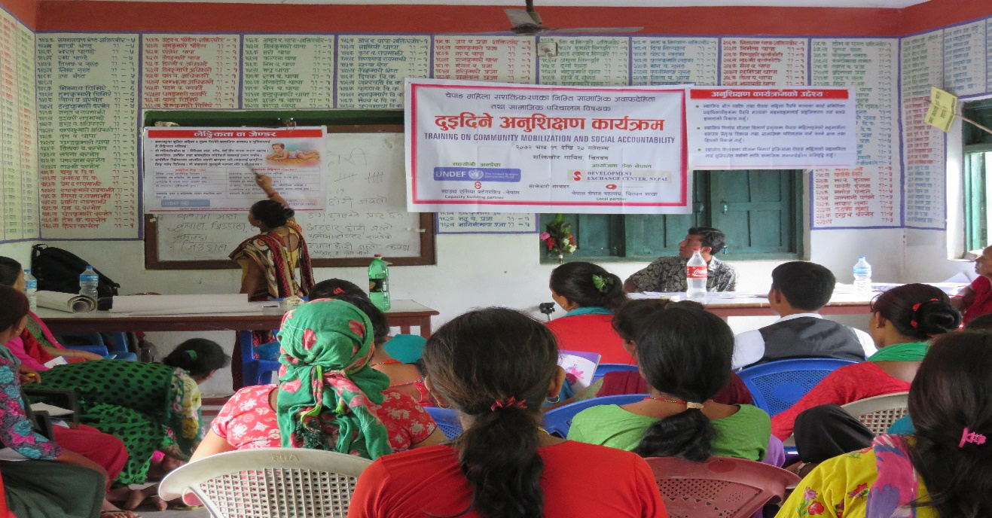
Local Resource Person in Facilitation skill, Shaktikhor VDC

Group photo with participants from Korak VDC

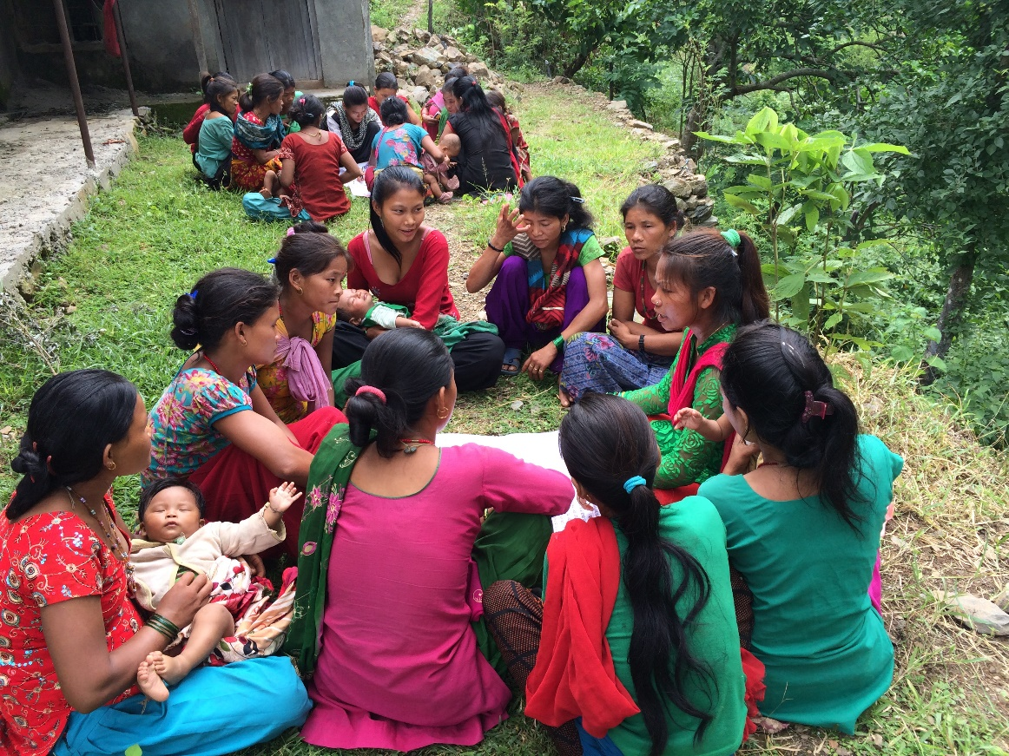
Group work on community score card, Chandibhanjyang VDC

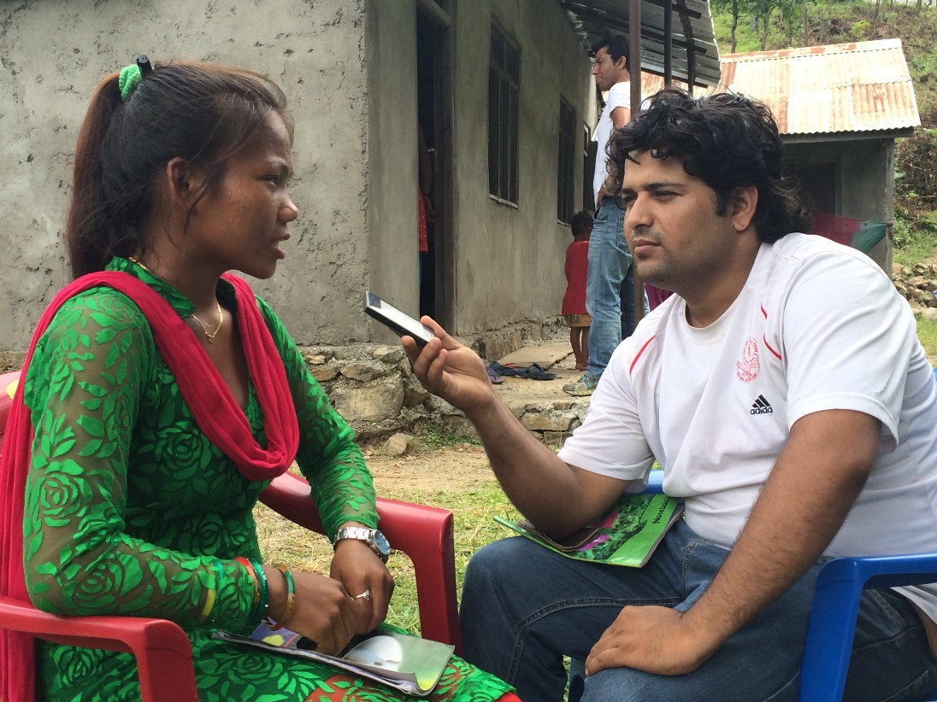
Interview with media personal

Annex III-Schedule of the training program
 | Session | Time | Objective | Methodology
Day 1 | Opening Session: Welcome, Introduction and objective of Cascade training | 10:00-11:00 am | Highlight objectives of the program and break ice for ensuring active participation | - Welcome Remarks  - Game
Day 1 | Highlight on Women Empowerment and gender | 11:00-12:00 am | Share concept of Gender and women empowerment | - Illustration (Flip charts) based presentation followed by interaction
Day 1 | Status of Chepang Women & Community mobilization and its concept | 12:00-01:30 pm | What, Why and How, Community mobilization? | - Illustration and Flex Chart based presentation  - Story telling  - Group Work
Day 1 | Lunch Break | 01:30-02:30 pm
Day 1 | Introduction of Chepang Women Advocacy Forum and discussion on REFLECT model | 2:30 - 3:30 pm | What, Why ,WoCAF and its duty | - Flex Chart based presentation followed with interaction
Day 1 | Intervention of Chepang women in local government planning process and role of Chepang Women Advocacy Forum | 03:30 - 04:30 pm | Why, How Chepang women increased to participate in Local Governance Decision Making & Planning processes | - Flex Chart based presentation followed with interaction  - Role play
Day 2 | Review of day 1 program | 10:00 – 10:15 am | Revision of Previous day | - Participatory method
Day 2 | Recap on Role of Chepang Women Advocacy Forum on accessing local development fund | 10:15 - 11:00 am
Day 2 | Introduction of Social Accountability and its tools | 11:00 - 11:30 am | What, Why and who is responsible for social accountability  Key tools of Social Accountability | - Flex Chart based presentation followed with interaction
Day 2 | Social Accountability (SA) tools exercise with indicators | 11:30 – 01:00 pm | Practice of Community Score Card with indicators | - Flex chart based presentation  - Group Exercise  - Role Play
Day 2 | Lunch Break | 01:0 – 1:30 pm
Day 2 | SA tools exercise & presentation | 01:30 – 03:00 pm | Analysis and present consolidate result of Community Score Card | - Group Exercise
 | Action Plan of Chepang Advocacy Fora | 03:30 – 04:30 pm | Discuss potential activities for activating Chepang Advocacy Fora | - Group Exercise

